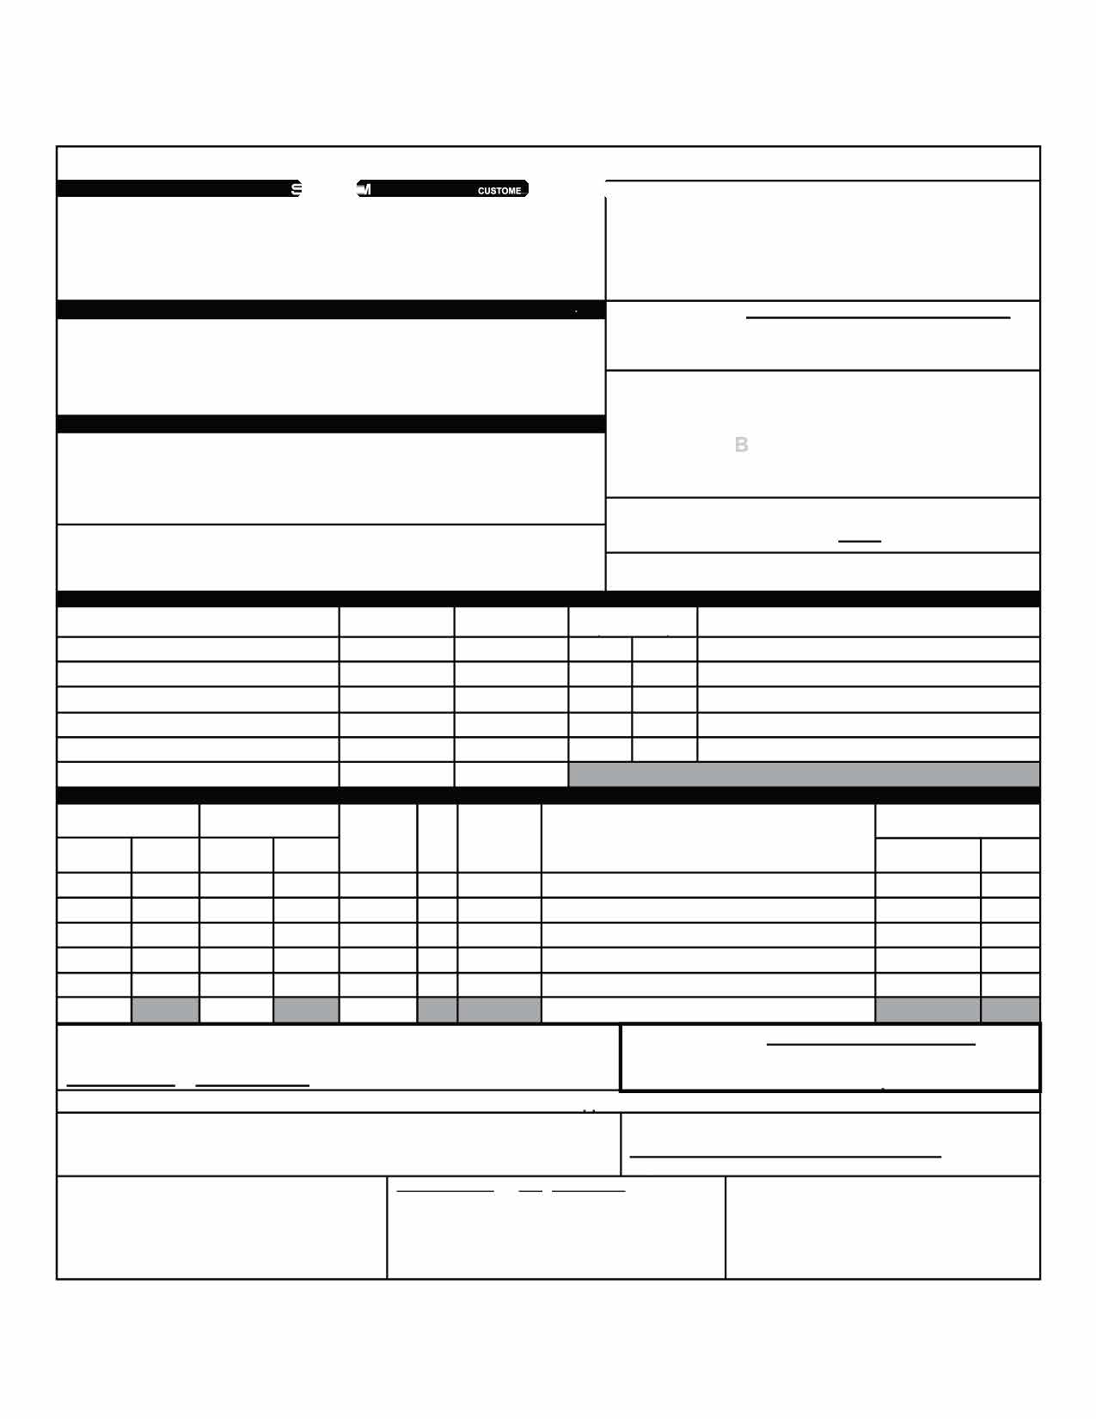

**BILL OF LADING**

**CENTRAL TRANSPORT BILL OF LADING**

Date:

**Page**

Name: Address: City/State/Zip: SID#:

**Bill of Lading Number:----------**

**BAR CODE SPACE**

**FOB:D**

**DOCK/TERMINAL PICKUP.•**

Location #:

**SHIP TO**

CARRIER NAME:

Trailer number: Seal number(s): **SCAC:**

Name: Address: City/State/Zip: CID#:

Name: Address:

**Pro#:**

**FOB:**

**THIRD PARTY FREIGHT CHARGES BILL TO:**

**AR CODE SPACE**

City/State/Zip:

SPECIAL INSTRUCTIONS:

**Freight Charge Terms:**

3rc1 Party

**Prepaid**

D

(check box)

**CUSTOMER ORDER INFORMATION**

**Collect**

Master Bill of Lading: with attached underlying Bills of Lading

**ADDITIONAL SHIPPER INFO**

**CUSTOMER ORDER NUMBER**

**# PKGS**

WEIGHT

**PALLET/SLIP**

/CIRCLE ONEl

y y y y y

**N N N N**

**N**

**GRAND TOTAL**

**CARRIER INFORMATION**

**DESCRIPTION OF ARTICLES, SPECIAL MARKS AND EXCEPTIONS**

**HANDLING UNIT**

(CTN, DRUM, PALE, ETC)

**PACKAGE**

(SKID, TOTE, CRT, ETC)

**QTY TYPE**

**LTL ONLY**

**QTY**

**TYPE**

**H.M. UN/ID**

**WEIGHT**

**NMFC#**

**CLASS**

(If Hazardous Materials - Proper Shipping Name)

**NUMBER**

**(X)**

**GRAND TOTAL**

Where the rate is dependent on value, shippers are required to state specifically in writing the agreed or declared

*The agreed or dee ared value of the property is specifically stated by the shipper to be not exceeding per

**COD Amount:**

$

value of the prope�as follows:

**Fee Terms: Collect: D Prepaid: D**

**Customer check acceptable: D**

**NOTE Liability Limitation for loss or damage in this shipment may be aoolicable. See 49 U.S.C. D 14706(c)(1)(A) and (8).**

RECEIVED, sub�ect to individually detennined rates or contracts that have been agreed upon in writing between The carrier shall not make delivery of this shipment without payment of

the carrier and s ipper, if applicable, otherwise to the rates, classifications and rules that have been established by the carrier and are available to the shipper, on request, and to all applicable state and federal regulations.

freight and all other lawful charges.

**Shipper**

**Signature**

**SHIPPER SIGNATURE/ DATE**

**CARRIER SIGNATURE/ PICKUP DATE**

Trailer Loaded:

**D** By Shipper

**D** By Driver

Freight Counted:

pTahciskais teodc, emrtai�ethdaat nthde above named materials are properlli classified,

labeled, and are in prorcr condition or transportation

**D** ByShipper

**D** By Driver/pallets said to contain

**D** By Driver/Pieces

Carrier acknowledges receipt of packages and required placards. Carrier

certifies emergency response infonnation was made available and/or

accor 9img to the applicable regulations of the OT.

carrier has the DOT emergency response guidebook or equivalent

documentation in the vehicle.

***Property described above Is received In good order, except as noted.***